Steven Zuelke

CSCD 212

Team: Refactor

1. Created Factories for Hero and Monster (Steven Zuelke)

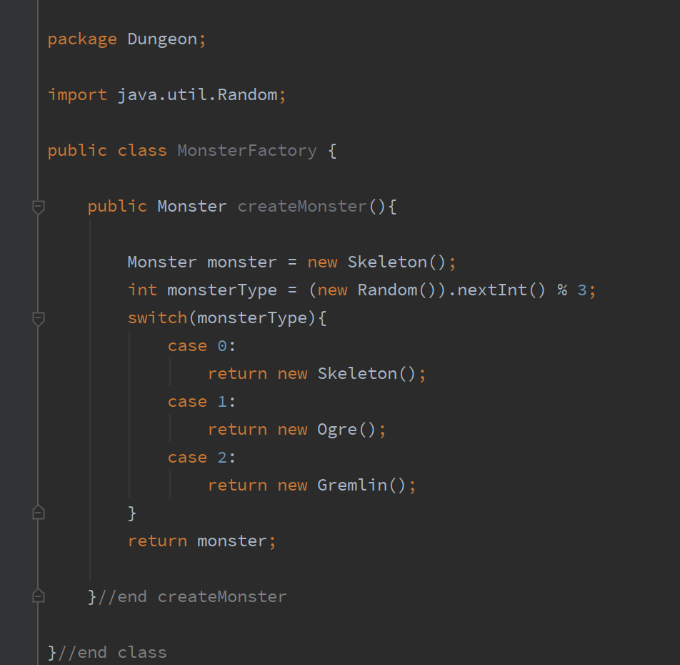

1. Added flyweight pattern for attacks, created attack classes and flyweight factory. Moved special attacks from normal class to dungeoncharacter, which calls the SpecialAttack class’s attack method

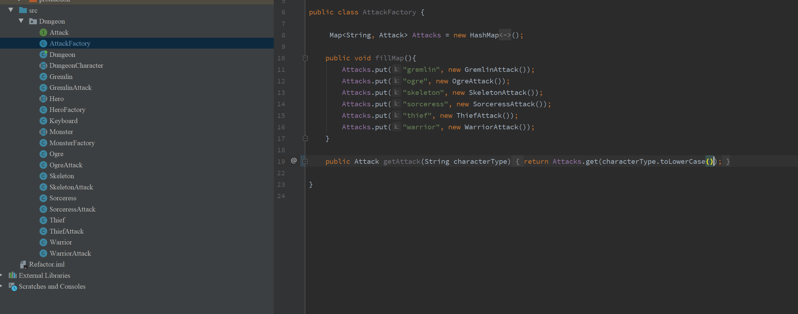

3. Added potions and pillars to hero class with tostring method

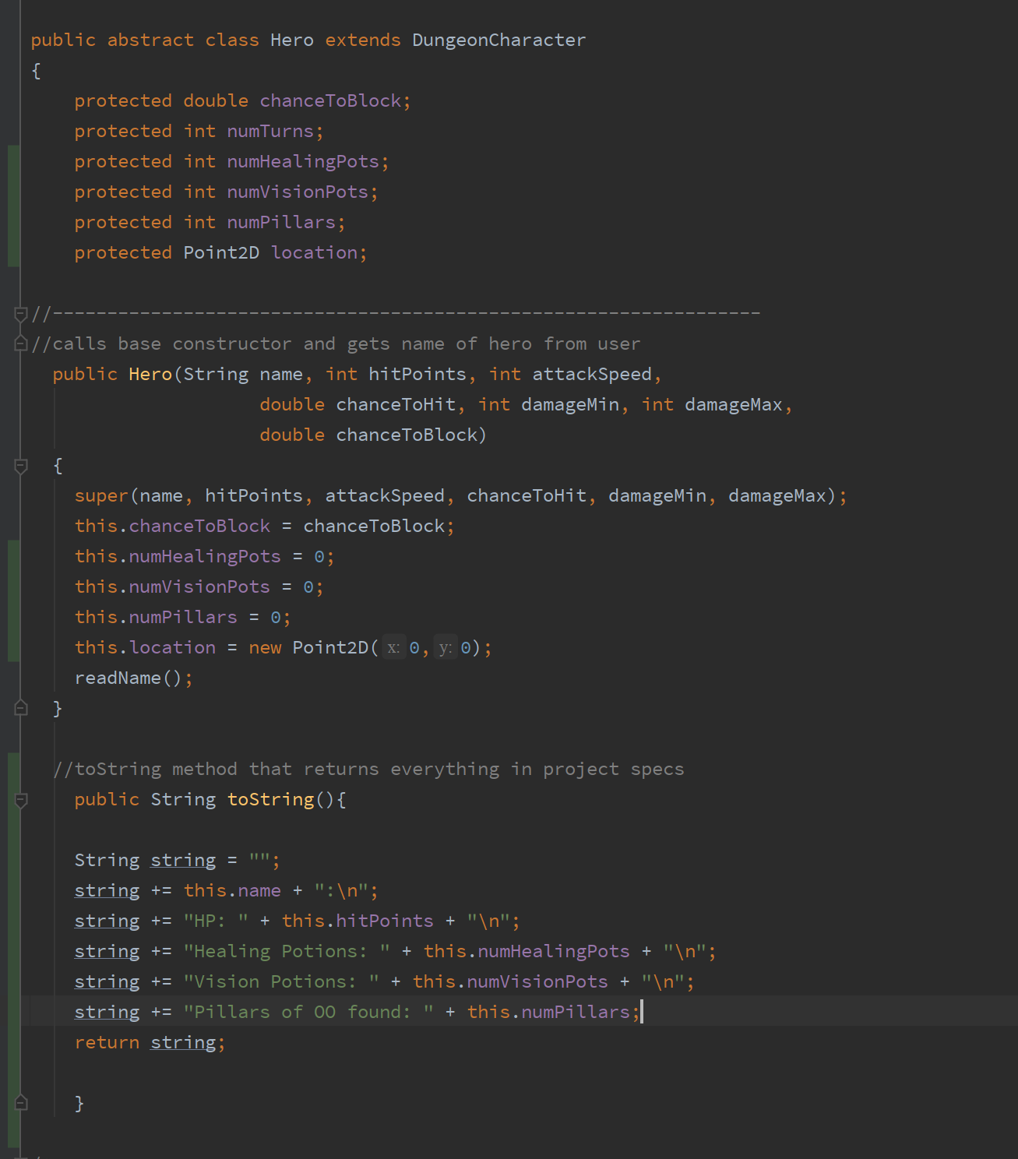

4. Put BattleChoices up into hero class referencing the specialAttack class’s name for the menu

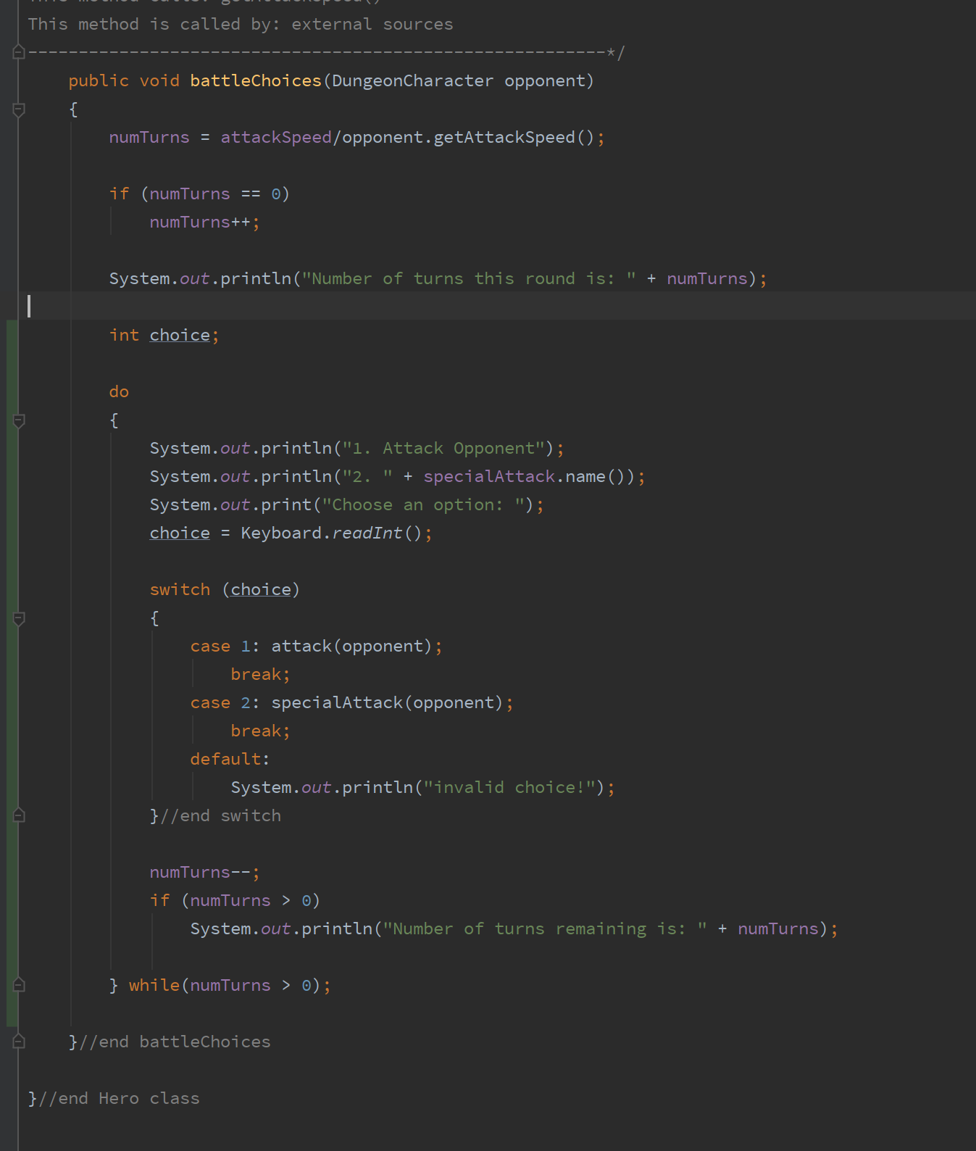

Sean Zahller

1. Created the following classes: Goblin(Monster), GoblinAttack Barbarian(Hero), BarbarianAttack, Dragon(Monster), DragonAttack. 5/17/20

